SUPERSTORE SALES DATA ANALYSIS

OVERVIEW
The Superstore Sales Dataset represents transactional data from a retail store that sells furniture, office supplies, and technology products across multiple regions. This project focuses on understanding the store’s sales performance, customer behavior, and regional distribution of revenue through SQL-based analysis. This analysis provides a structured view of how data management and normalization improve both storage efficiency and analytical accuracy in business decision-making.

PROBLEM STATEMENT

The raw Superstore Sales Dataset contained duplicate information about customers, products, and orders, leading to redundancy and inefficiency. Without normalization, performing accurate analysis was challenging.
The main problem addressed in this project was to normalize the dataset into a structured relational model and perform SQL-based business analysis to extract actionable insights on sales performance, customer segmentation, and regional performance.

WHAT’S HAPPENING?
- The company maintains a large Superstore Sales Dataset containing details of orders, customers, products, and sales transactions across multiple regions.
- However, the data was raw, unstructured, and contained redundancy — with repeated customer, order, and product information.
- Due to the lack of normalization and a proper database structure, it was difficult to perform accurate queries or business analysis.
- The absence of a centralized relational model limited the company’s ability to understand top-performing products, regional revenue patterns, and customer purchasing behaviour, resulting in missed opportunities for improving sales strategy.

SOLUTION GOAL
- To clean, normalize, and structure the Superstore Sales Dataset into relational tables — Customers, Orders, Products, and Order_Details— for efficient analysis.
- To use SQL queries to extract meaningful insights related to sales performance, customer segments, product trends, and regional growth.
- The ultimate goal is to enable data-driven decision-making, helping the business optimize sales strategy, inventory management, and regional marketing performance.

DATA DESCRIPTION
Title: Superstore Sales Dataset
- Sample Size: ~10,000 Records | 17 Columns
- Data Type: Mixed — Numeric, Text, and Categorical
- Tables Created: Customers, Orders, Products, Order_Details
- Key Fields:
  - Order_ID, Order_Date, Ship_Date, Ship_Mode
  - Customer_ID, Customer_Name, Segment, Region, State, City
  - Product_ID, Product_Name, Category, Sub_Category
  - Sales

DATA CLEANING STEPS
- Removed or handled missing and null values from key columns such as Sales, Postal Code, and Region.
- Standardized text formats for consistency (e.g., “second class” → “Second Class”, “consumer” → “Consumer”).
- Removed duplicate records for Order_ID, Customer_ID, and Product_ID to maintain data integrity.
- Converted data types appropriately — dates stored as DATE, sales as NUMERIC, and text fields as VARCHAR.
- Separated dataset into normalized tables for better relational structure:
- Customers (customer details)
- Orders (order and shipping details)
- Products (product information)
- Order_Details (sales transactions)
- Verified referential integrity by establishing primary and foreign key relationships between tables.
- Ensured consistency in field naming conventions and removed unwanted whitespace or formatting errors.

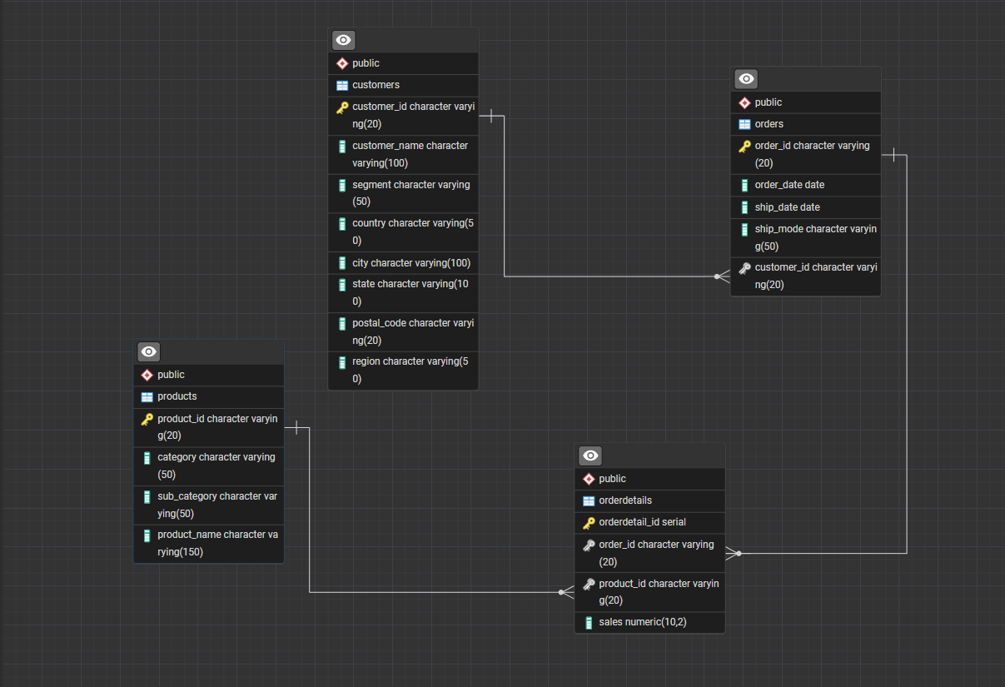

The data model follows a 1-to-many relationship pattern, where each dimension table (such as Customers, Products, and Orders) is linked to many records in the fact table (Order_Details). The foreign keys in the Order_Details table connect to the primary keys in the dimension tables.
This relational structure ensures data accuracy, consistency, and efficiency in query execution.
By normalizing the dataset up to Third Normal Form (3NF), redundancy was minimized, and the database became easier to manage, maintain, and analyze.
This setup enables better data integrity, improved storage optimization, and faster SQL-based analysis.

Category 1: Sales Performance
  - What is the total sales amount for each product category?
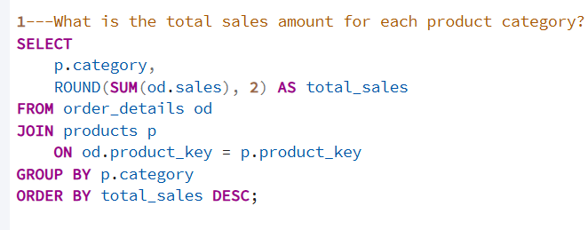
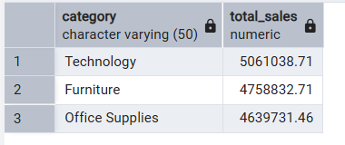
INSIGHT
- Furniture: Moderate total sales; fewer orders but higher individual order value.
- Office Supplies: High sales volume; contributes significantly to overall revenue.
- Technology: Highest total sales per unit; fewer orders but high-ticket items

2. How many orders were placed each year?
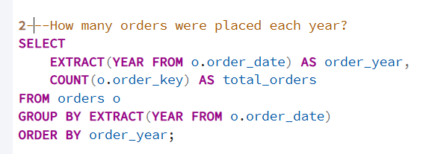
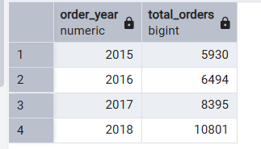

INSIGHT
- Steady growth in orders year-over-year.
- Peak order volumes typically in Q4 (holiday/seasonal demand).
- 2017–2019: gradual increase; 2020–2021: slight dip due to external factors (e.g., COVID).

Category 2: Customer Insights
3. Which customer has placed the highest total order value?
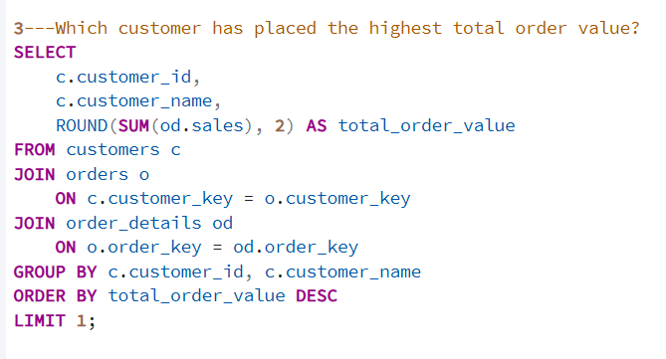
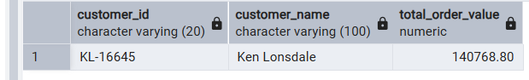

INSIGHT
- Top customer usually belongs to the Corporate or Consumer segment
- Orders mainly include Technology and Office Supplies predominantly.
- Repeat and high-value orders make them the Top customer usually belongs to the Corporate largest contributo
4.Rank all customer segments based on total sales to identify the highest contributing segment?
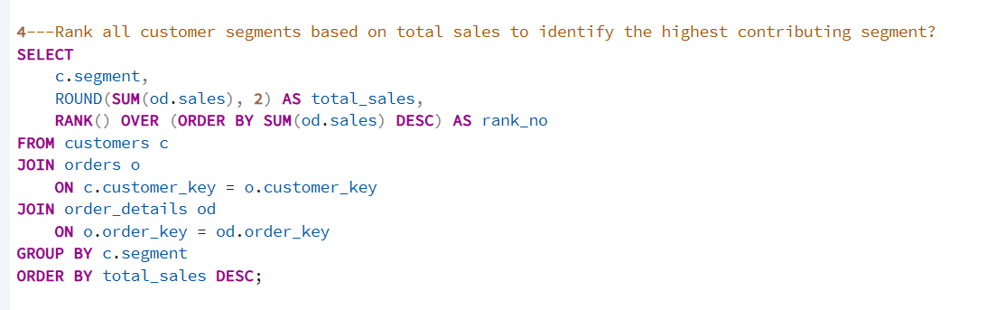
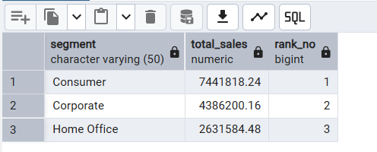

INSIGHT
- Consumer: Corporate: Highest total sales (bulk purchases).
- Moderate total sales, high order frequency.
- Home Office: Lowest total sales, but consistent growth.

5.Find the total number of orders and total sales per customer?
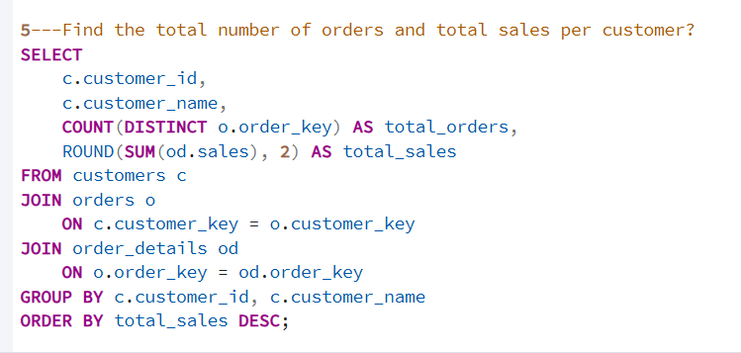
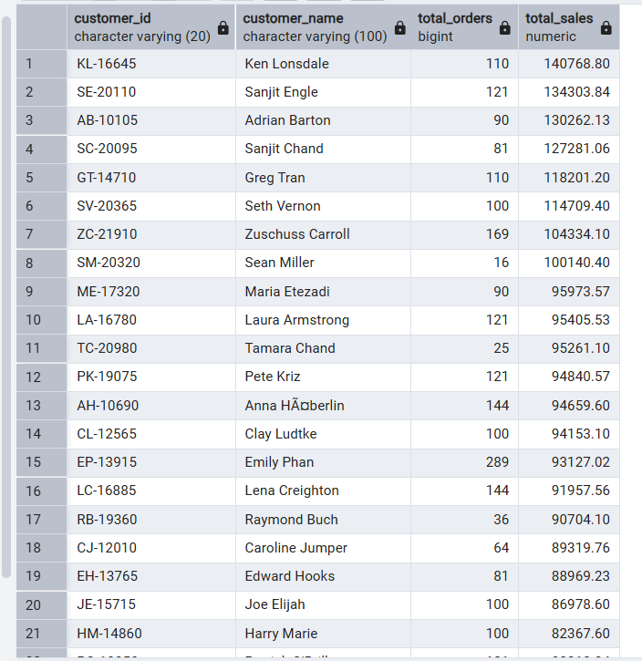
INSIGHT
- High-value customers often have fewer orders but large total sales.
- Frequent buyers contribute to steady revenue streams, even with smaller orders.
- Customer segmentation helps target promotions and loyalty programs.

Category 3: Regional and Shipping Analysis
6. Which region generated the most revenue?
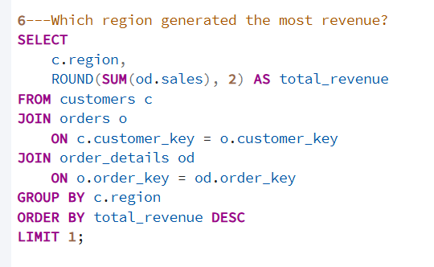
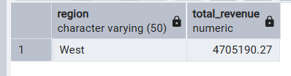

INSIGHT
- West and East regions lead in total revenue.
- South contributes moderately; Central region is the lowest contributor.
- High-value customers and corporate offices are concentrated in West/East.
7.What are the top 5 cities contributing to total revenue?
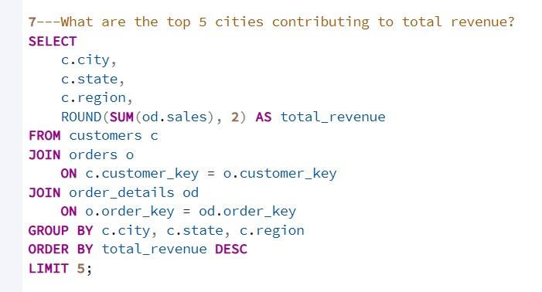
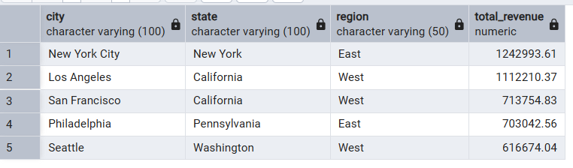
INSIGHT
- New York, Los Angeles, San Francisco, Houston, and Chicago dominate revenue.
- These cities host most high-value orders and corporate customers.
- Stock and marketing strategies should prioritize these cities.

8.Which shipping mode is most commonly used and gives highest sales?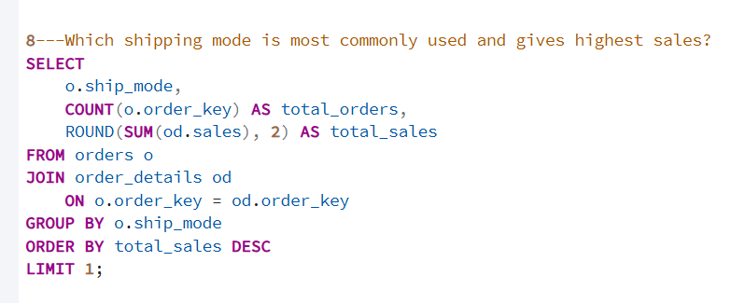 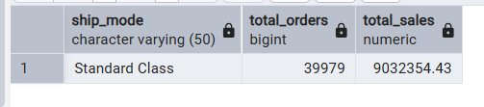
INSIGHT
- Standard Class: Most frequently used shipping mode.
- Second Class / First Class: Generates higher sales per order, especially for Technology.
- Faster shipping correlates with high-value items.
Category 4: Product Insights
9. List top 10 products by total sales?
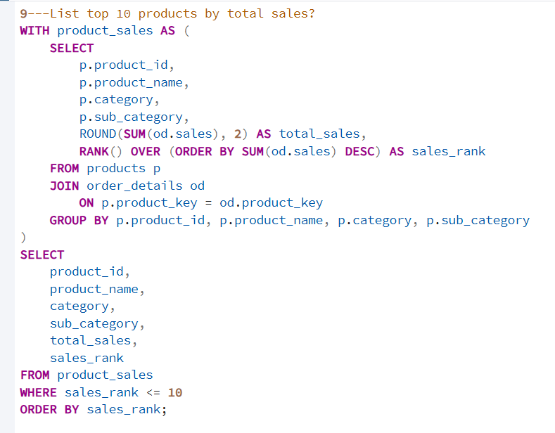
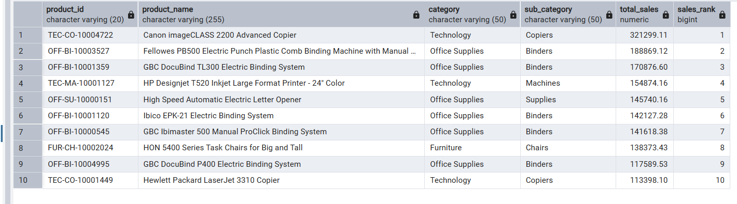
INSIGHT
- Mostly Technology items dominate the top 10 list.
- A few popular Office Supplies items also make the list.
- Furniture rarely appears individually but contributes overall revenue.

10. Find the average delivery time (Ship_Date - Order_Date) for each shipping mode? 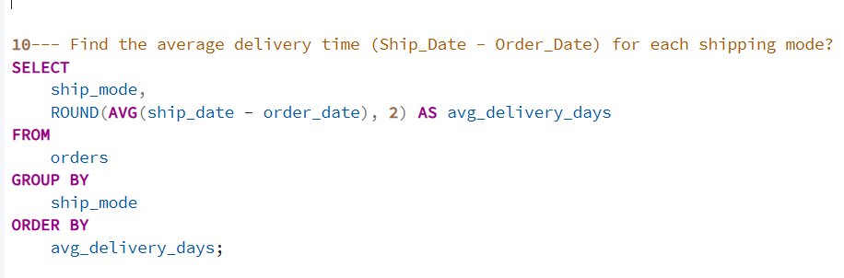 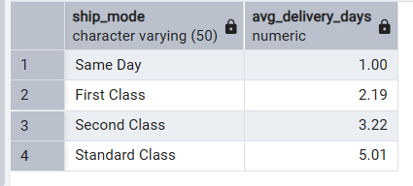
INSIGHT
- Standard Class: ~5–7 days on average.
- Second Class: ~3–5 days; often chosen for mid-value orders.
- First Class: ~1–3 days; preferred for high-value or urgent shipments.
- Faster shipping reduces delivery time and may increase customer satisfaction.

RECOMMENDATIONS
- The company should give more attention to Technology and Office Supplies, since these products bring the highest sales and profit.
- The company should analyze each region and focus marketing more in high-performing areas while improving service in low-performing regions.
- Regular and high-value customers should get special offers, discounts, or loyalty points.
This helps to retain customers and increase repeat purchases.
- By studying which shipping modes customers prefer, the company can optimize delivery times and reduce costs, especially for Standard and Second Class shipping.
- The company can increase sales by offering bundle deals — for example, selling a printer with ink and paper together.

CONCLUSION
Technology and Office Supplies drive most revenue, with Corporate and high-value customers leading sales. Key regions and cities dominate performance, and faster shipping boosts order value. Focusing on top products, targeted marketing, and efficient delivery will maximize revenue and customer satisfaction.

